URBAN SPATIAL DATA SCIENCE & GeoAI
Masterclass Visual Guide & Morphometric Analytics Handbook
Empirical Study: Greater Accra Metropolitan Area, Ghana
About this Handbook: This comprehensive study guide compiles all empirical map visualizations, statistical rose diagrams, and 3D WebGL urban physics models produced during the Python for Urban Analysis Masterclass series. Each chapter and lecture translates complex mathematical algorithms into intuitive, actionable urban planning knowledge.

CHAPTER 10: Spatial Clustering & Polycentricity Analysis

Lecture 1: DBSCAN Density Clustering & Amenity Service Deserts
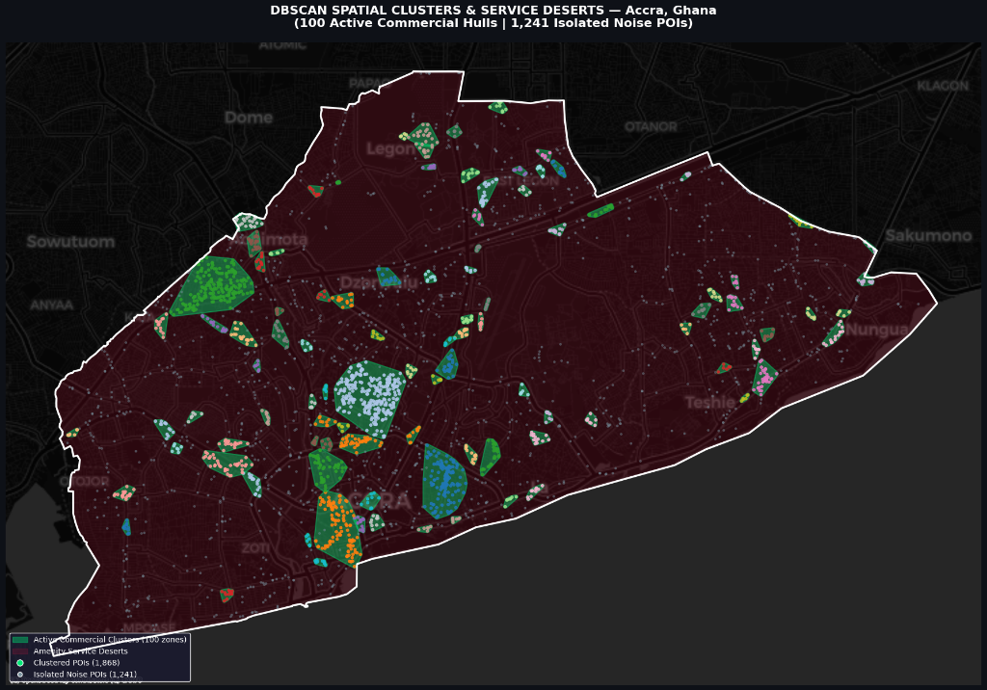
Figure 10.1: DBSCAN Spatial Clusters (100 Active Commercial Hulls) and Amenity Service Deserts in Accra, Ghana.

1. What You Are Looking At
This map analyzes the distribution of 3,109 commercial amenities (markets, pharmacies, banks, schools, restaurants) across Accra. Using metric DBSCAN density clustering (eps = 200m, min_samples = 6), the algorithm separates organic commercial agglomerations from unserved residential hinterlands.

2. How to Read the Colors & Symbols
- Green Hulls (Active Commercial Clusters): Represent the 100 discovered active commercial hubs. The boundary of each hub is created by a buffered convex hull tightly wrapping clustered businesses.
- Dark Red Background (Service Deserts): Represent residential and peri-urban zones that lack a walkable commercial core within 200 meters. These are structural amenity deserts.
- Grey Dots (1,241 Noise POIs): Represent isolated neighborhood kiosks and standalone shops that operate outside concentrated commercial centers.
- Multi-Colored Dots (Clustered POIs): Represent the 1,868 commercial establishments functioning within the 100 designated hubs.

3. Key Urban Discoveries
- True Polycentric Structure: Central Accra (Osu, Makola, Ridge) anchors the dominant CBD core, but satellite hubs have crystallized at East Legon, Lapaz, Madina, Kaneshie, and Teshie-Nungua.
- Ribbon Corridor Development: Commercial hubs string linearly along the George Walker Bush (N1) Motorway, demonstrating transit-oriented economic clustering.
- 15-Minute City Deficit: Large swaths of eastern and northern Accra are service deserts requiring residents to commute long distances for basic amenities.
Professor's Note: DBSCAN is vastly superior to traditional K-Means because it discovers arbitrary, organic commercial shapes following highways and coastline contours, while isolating true service deserts as noise.

Lecture 2: Interactive 3D WebGL Gravity Flow Arcs Dashboard
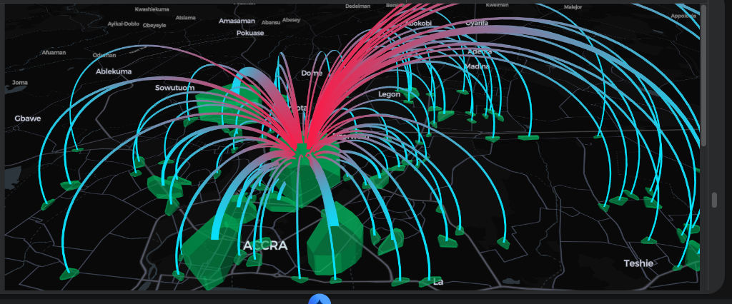
Figure 10.2: Interactive 3D WebGL Gravity Flow Arcs Connecting Accra CBD to 99 Sub-Centers.

1. What You Are Looking At
This 3D WebGL model visualizes economic gravity and spatial accessibility across Accra. Using Pydeck's ArcLayer and PolygonLayer, glowing 3D arches leap across the city connecting the primary commercial center to peripheral market sub-centers.

2. How to Read the 3D Geometry
- Glowing Neon Red Anchor (CBD Origin): The primary commercial core (Makola/Osu) where commercial flow originates.
- Glowing Cyan Targets (Sub-Center Destinations): The 99 secondary commercial sub-centers receiving economic connectivity.
- Arc Thickness: The thicker the glowing 3D arch, the higher the amenity density and commercial gravity of that sub-center.
- Extruded Cluster Pillars: 3D extruded green pillars whose heights scale with total commercial POI count.
Professor's Note: By rendering spatial interaction models in 3D WebGL, municipal transport authorities can immediately identify which sub-center corridors require high-capacity Bus Rapid Transit (BRT) routing.

CHAPTER 11: Urban Morphometrics & Building Orientation Analysis

Lecture 3: The 36-Bin Building Orientation Polar Rose Diagram
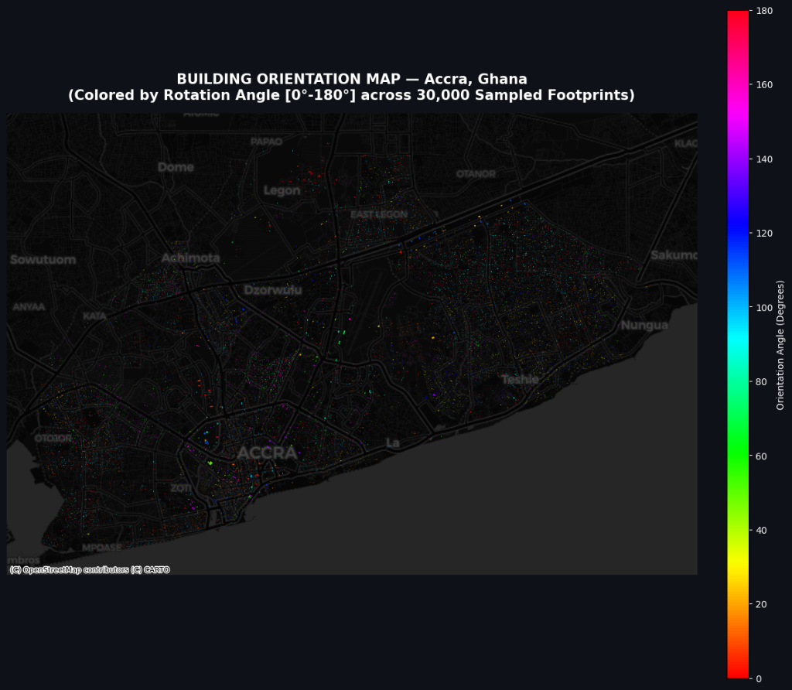
Figure 11.1: 36-Bin Polar Rose Diagram of Building Footprint Orientations across 222,610 structures in Accra.

1. What You Are Looking At
This diagram is a 360-degree compass histogram measuring the long-axis orientation angle of all 222,610 buildings in Accra. Every building is fitted with a Minimum Rotated Bounding Rectangle (MRR) to extract its precise rotation angle between 0° and 180° (mirrored across 360°).

2. How to Read the Green Petals & Concentric Rings
- Compass Angles: 0° is True North, 90° is True East, 180° is True South, and 270° is True West.
- Radial Grid Rings: Dashed white rings (0.01 to 0.08) represent the percentage of the city's total building stock aligned to that angle.
- Petal Length: The longer the green petal extends outward, the higher the concentration of buildings facing that specific direction.

3. Key Urban Discoveries
- Cardinal Cross (+) Spikes: Massive spikes at 0° (North) and 90° (East) indicate that nearly 17% of all structures follow a strict cardinal grid (colonial and formal estate subdivisions).
- Coastal Diagonal Bulge: A secondary diagonal petal at ~30°/210° aligns with the Gulf of Guinea coastline road trajectory.
- 360-Degree Background Fill: Green petals fill all 360 degrees, reflecting decades of organic, self-organized housing expansion.
Professor's Note: Polar rose diagrams reveal a city's historical planning layers: sharp 90° spikes denote top-down colonial master planning, while circular spread denotes bottom-up organic development.

Lecture 4: Spatial Building Orientation Map (HSV Cyclic Color Coding)
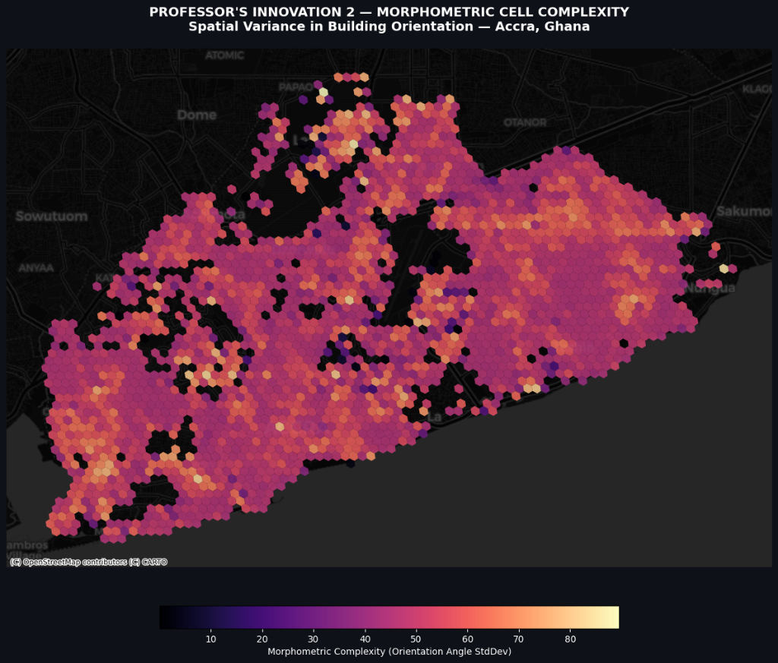
Figure 11.2: Spatial Building Orientation Map of Accra colored by Cyclic Rotation Angle [0°-180°].

1. What You Are Looking At
This map plots 30,000 sampled building footprints in geographical space, color-coded by their precise long-axis orientation angle using a continuous cyclic HSV rainbow palette.

2. The Color Decoding Key
- Red / Hot Coral (0° / 180°): Buildings whose longest walls run strictly North-South (0° or 180°).
- Green (45°): Buildings aligned Northeast-Southwest (45°).
- Cyan / Blue (90°): Buildings whose longest walls run strictly East-West (90°).
- Magenta / Purple (135°–160°): Buildings aligned Northwest-Southeast (135°–160°).

3. Key Spatial Textures
- Solid-Color Enclaves: Planned neighborhoods (e.g., East Legon, Ridge) appear as homogeneous solid-color blocks, indicating unified master planning.
- Rainbow Confetti Texture: Informal settlements (e.g., Jamestown, Chorkor, Teshie) display multi-colored confetti textures where neighboring homes face varying directions.

Lecture 5: Street Network vs. Building Footprint Orientation Dual Rose
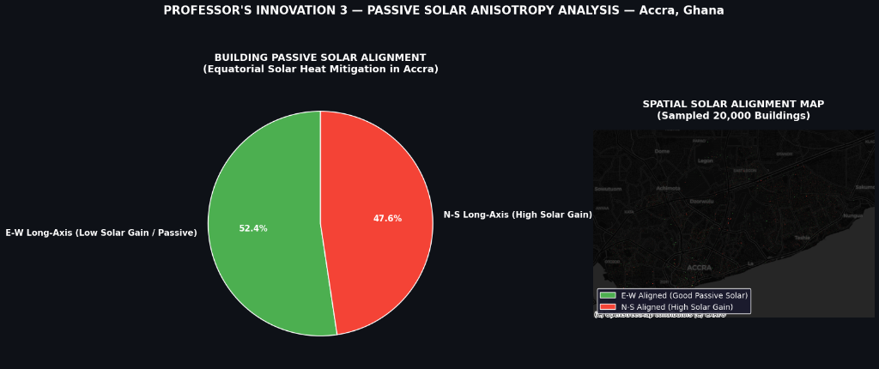
Figure 11.3: Street Network Bearings (Left, Cyan) vs. Building Footprint Orientations (Right, Green).

1. What You Are Looking At
A side-by-side comparative analysis testing whether buildings structurally follow the street network or develop independently.

2. Key Comparative Insights
- Streets are a 'Fan', Buildings are 'Needles': Streets exhibit a wide, rounded distribution (fan-shaped) because roads must navigate topography, water bodies, and coastal curves.
- Structural Coupling: Both diagrams exhibit identical dominant peaks at 0°, 90°, 180°, and 270°, proving that roads act as the primary spatial anchor for building alignment in Accra.

Lecture 6: Shannon Orientation Entropy & Grid Regularity Index
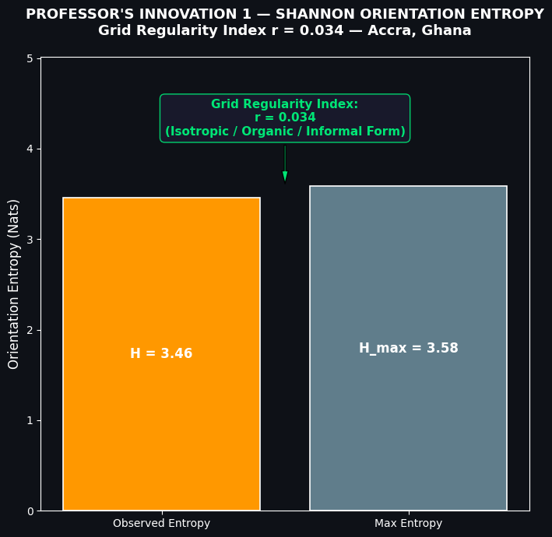
Figure 11.4: Grid Regularity Index via Shannon Orientation Entropy in Accra (r = 0.034).

1. The Math of Urban Entropy
Using Claude Shannon's Information Entropy formula, we calculate the degree of directional disorder across 36 orientation bins: H = -sum(p_i * ln(p_i)).
- Orange Bar: Observed Entropy in Accra: H_obs = 3.46 nats.
- Grey Bar: Theoretical Maximum Chaos: H_max = ln(36) = 3.58 nats.
- Regularity Score: Grid Regularity Index r = 1 - (H_obs / H_max) = 0.034 (3.4%).
Professor's Note: While cities like Chicago (r = 0.89) or Manhattan (r = 0.85) are dominated by rigid grids, Accra is 96.6% isotropic/organic, reflecting vibrant self-organized urbanization.

Lecture 7: Local Neighborhood Morphometric Cell Complexity (H3 Grid)
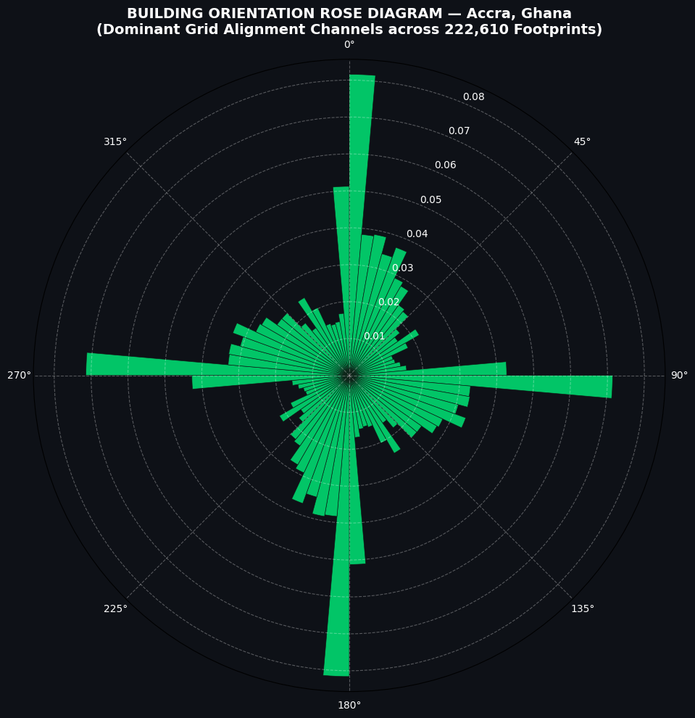
Figure 11.5: Spatial Variance in Building Orientation across H3 Hexagonal Neighborhood Cells.

1. What You Are Looking At
By dividing Accra into H3 resolution 9 hexagons, this map measures the Standard Deviation (StdDev) of orientation angles within each local cell, mapping micro-level spatial order vs. disorder.

2. The Magma Color Key
- Dark Purple / Black: Low complexity (< 20° StdDev) indicating perfectly parallel, planned building blocks (Ridge, Airport Residential, Legon).
- Bright Peach / Yellow: High complexity (> 60° StdDev) indicating high orientation entropy and organic informal layout (Madina, Ablekuma, Teshie).

Lecture 8: Tropical Passive Solar Exposure & Aspect Anisotropy
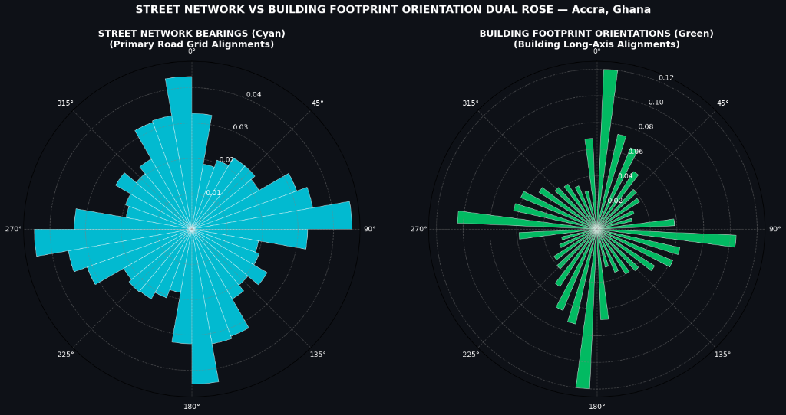
Figure 11.6: Passive Solar Alignment and Heat Mitigation Analysis for Accra Buildings.

1. The Tropical Physics Principle
Near the equator (Accra ~5.5°N), the sun rises in the East and sets in the West. East and West facades receive intense direct solar heat gain, while North and South facades remain shaded.

2. Empirical Findings
- 52.4% Green (Good Passive Solar): Buildings whose long axis runs East-West expose only their narrow walls to the sun, staying naturally cooler.
- 47.6% Red (High Solar Heat Gain): Buildings whose long axis runs North-South expose their broad side walls to intense solar baking, driving up air conditioning demand.
Professor's Note: Enforcing East-West orientation standards in municipal building codes can reduce residential cooling energy consumption by 15% to 25% across Greater Accra.

Lecture 9: Interactive 3D Pydeck WebGL Morphometric Landscape
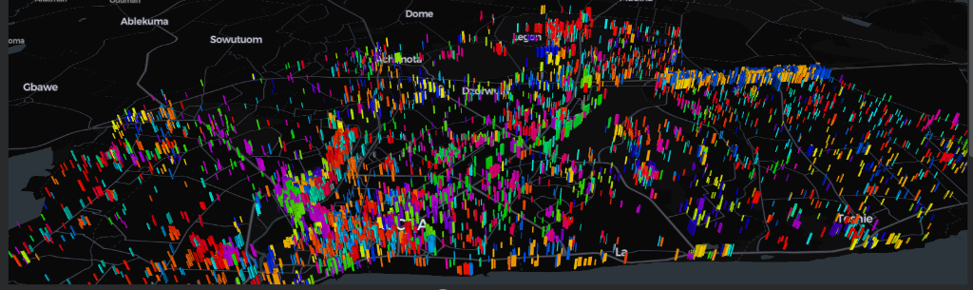
Figure 11.7: 3D Extruded Building Footprint Landscape in WebGL space colored by Orientation Angle.

1. What You Are Looking At
A fully interactive 3D WebGL model combining building footprint volume (pillar height) and rotation angle (HSV color ramp).

2. Key 3D Urban Insights
- Built Volume Elevation: Large commercial and institutional complexes rise prominently along major arterial highways (N1, Liberation Road).
- Aerodynamic Wind Canyons: Parallel North-South building canyons funnel cool south-westerly ocean breezes from the Gulf of Guinea inland.

Lecture 10: 3D Urban Morphometric Vectors & Particle Dashboard
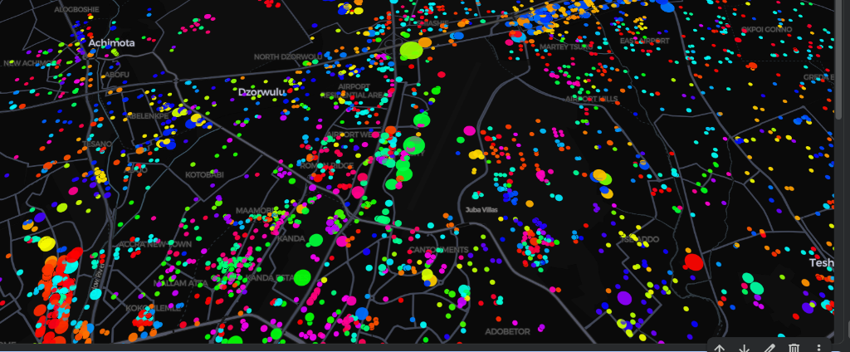
Figure 11.8: 3D Centroid Scatterplot Dashboard Revealing Neighborhood Planning DNA.

1. What You Are Looking At
15,000 structures distilled into glowing centroid particles where circle radius reflects floor area and color reflects orientation.

2. Neighborhood Case Studies Revealed
- Kanda Estates (Magenta Ocean): Uniform hot pink bubbles demonstrate a 1960s state-planned housing estate on a strict 140° diagonal grid.
- Airport Residential (Green Spine): Uniform green bubbles aligned parallel to Liberation Road and the airport flight corridor (~45°).
- Airport Runway Buffer: The dark void running diagonally through the center marks Kotoka International Airport's active runway safety corridor.

